**CLASSIFICATION ASSIGNMENT RESEARCH PAPER**

1. **PROBLEM STATEMENT**

* Machine Learning
* Supervised Learning
* Classification

1. **DATASET INFORMATION**

This dataset has 399 Rows and 25 Columns.

1. **PRE-PROCESSING METHODS**

In this module, I used Dummies and Standard Scaler methods.

1. **RESEARCH VALUES**
2. LOGISTIC REGRESSION:

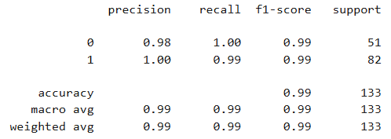

In LOGISTIC REGRESSION, the ACCURACY VALUE is 0.99

1. DECISION TREE CLASSIFIER:

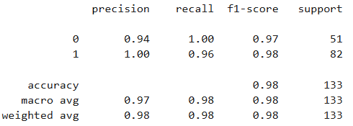

In DECISION TREE CLASSIFIER, the ACCURACY VALUE is 0.98

1. RANDOM FOREST CLASSIFIER:

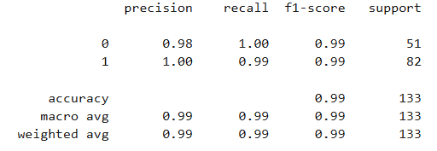

In RANDOM FOREST CLASSIFIER, the ACCURACY VALUE is 0.99

1. K NEAREST NEIGHBORS:

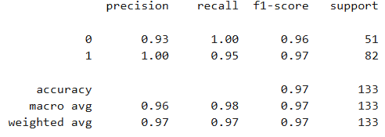

In K NEAREST NEIGHBORS, the ACCURACY VALUE is 0.97

1. **FINAL MODEL**

“LOGISTIC REGRESSION & RANDOM FOREST CLASSIFIER” are considered as best models. Because, among the 4 algorithms, these 2 give the best accuracy value.